**Microservices Architecture for Cloud Surfer**

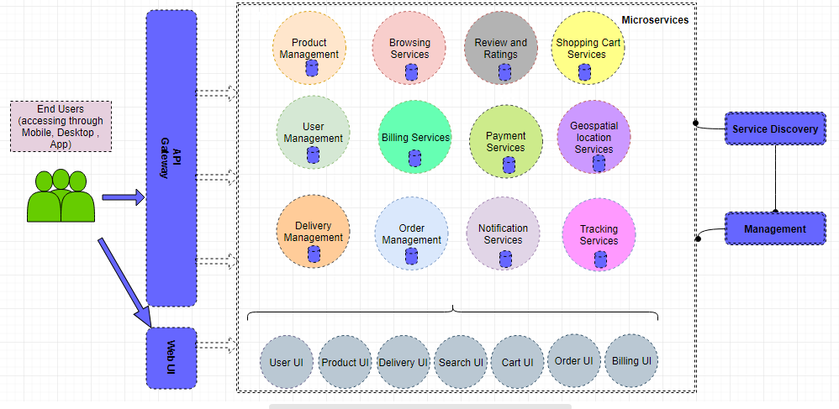

**Motivation Behind the Architecture**

1. Easy to build and maintain services. Loosely coupled services architecture.

2. The designed services are organized around business capabilities.

3. Improved productivity and scalability.

4. Flexibility in using technologies for individual services .

5. Independent software development life cycle.

6. Database per service enhances containerization.

**Components**

* The API Gateway - Acts as a security gateway for the complete microservices architecture (includes load- balancer for routing requests)
* The Service Discovery - Holds the roadmap of the microservices architecture
* The Management - Provides health, info and other useful information of each microservices
* Web UI - UI provided to the user